DS 522 Data Acquisition and Analytics
HOS01A – Python Basics

06/06/2024 Developed by Catherine Ata
03/04/2024 Reviewed by Yogesh Goel
03/18/2025 Reviewed by Naveena Moddu

School of Technology & Computing (STC) @ City University of Seattle (CityU)
Before Starting
• The directory path shown in screenshots may be different from your directory.
• Some steps are not explained in the tutorial. If you are not sure what to do:
1. Consult the resources listed below.
2. If you cannot solve the problem after a few tries, email your course TA for help.

Learning Outcomes
Students will be able to:
• Set up the working environment for Python
• Understand basic python concepts
• Understand data conversion in Python

Resources
- McKinney. (2022). Python for Data Analysis (3rd edition).
- Python.org. (2024). Python documentation. https://docs.python.org/3/
- Visualstudio.com. (2024). Setting up Visual Studio Code. https://code.visualstudio.com/docs/setup/setup-overview
- Tutorial Point. (2024). Python Tutorial. https://www.tutorialspoint.com/python/index.htm
- Real Python. (2024). Python Basics. https://realpython.com/tutorials/basics/
- W3 Schools. (2024). Python Variables. https://www.w3schools.com/python/python_variables.asp

Getting Started
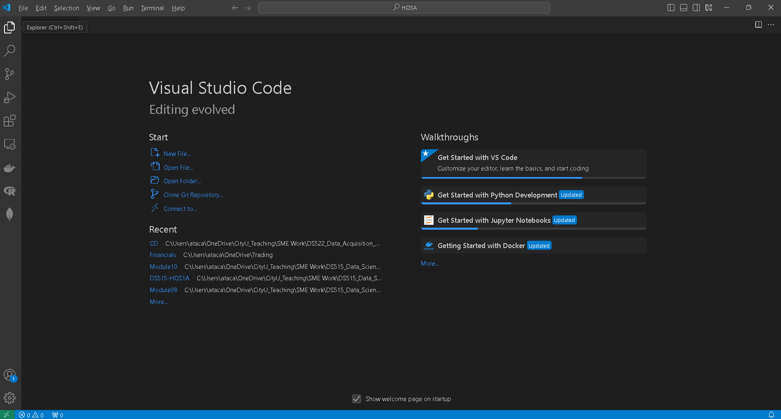
- Open VS code and within VS Code, open the DS522 course folder created earlier. On the menu tab, select File, then Open New Folder. Navigate to your work directory or GitHub repository that you have cloned. For example: C:\Users\my_workspace\Desktop\DS522
OR C:\Users\my_workspace\Desktop\DS522\github_repository_name
NOTE: If you have cloned a GitHub repository that is provided specifically for this course, navigate to that directory and skip steps 2 to 4. This will be the folder where you will be storing all your HOS01A work.
- Once in your work directory, go to the menu tab again, select Terminal, select New Terminal to open a Command Line Interface (CLI) like the Command Prompt or PowerShell for Windows OS.

- Inside your “DS522” directory, create a new directory and name it “Module01”. Use the following command:
>mkdir Module01
- Move to the new directory. Use the following command:
>cd Module01

This will be the folder where you will be storing all your HOS01A work.
Python Basics

Variables
Variables are containers for storing data values. Unlike other programming languages, In Python, you are not required to declare a variable type and you can change the type after they have been set. There are no commands for declaring a variable and its types. A variable is created the moment you first assign a value to it.

Variable Names
A variable can have a short name (like x and y) or a more descriptive name (age, carname, total_volume).
Rules for Python variables include:
- A variable name must start with a letter or the underscore character.
- A variable name cannot start with a number.
- A variable name can only contain alpha-numeric characters and underscores (A-z, 0-9, and _).
- Variable names are case-sensitive (age, Age and AGE are three different variables).
- A variable name cannot be any of the Python keywords.

Creating Variables
1. Below is an example of how variables are created. You may not have to type the code below; this is just for demo purposes to help you understand.

First, we create a Python file to easily run Python codes and use them for later. Python files have ‘.py’ extension. For this example, we can use ‘hello.py’ as the file name.
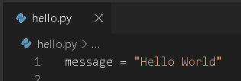

Alternatively, you can directly type the above code in the Python interactive shell, as shown in the image below. Type: python3 and press Enter. Type the code and to run the code, you just need to press enter.
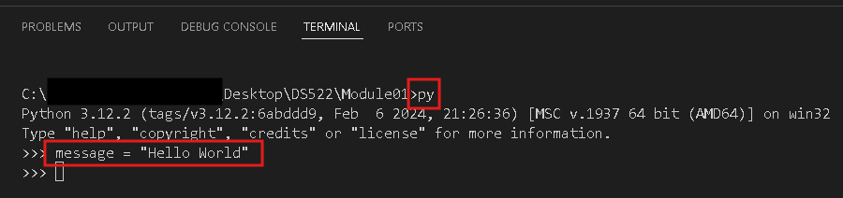

The “message” is the variable. As mentioned earlier, variables do not need to be declared with any data type and can even change type after they have been set.

To display the contents inside the message, use the ‘print’ function. Now, let us run the Python script that we created. To do that we can simply click Run.
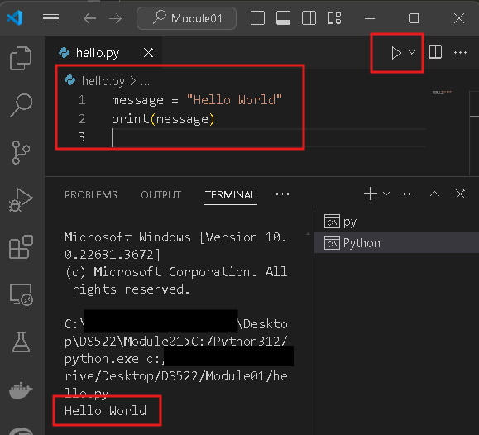

Alternatively, we can compile and run the Python script through the terminal, by using the command: python hello.py
Output:
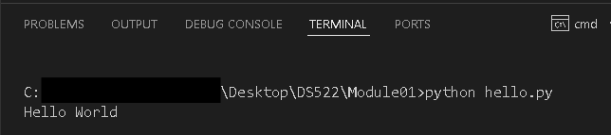

Note: depending on your installation/OS, you may need to use “python” or “py” instead of “python3”.

2. Let us look at another example to understand how variables work.

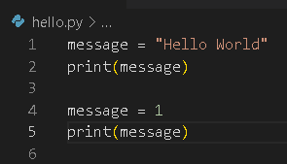

The first ‘message’ variable has a value with a string data type while in the second ‘message’ variable, the value was changed to an integer data type as we assigned the value 1.

The variable ‘message’ has been used twice and the most recently assigned value to the variable ‘message’ is its final value. The value ‘Hello World’ has been replaced with 1.

In Python, we can change the value of a variable in our program at any time, and Python will always keep track of its current value.

Output:
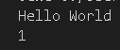

To check the data types for each variable call, we can add a line or 2 to the code:
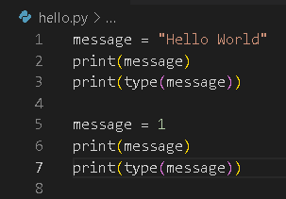

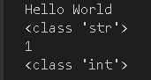
Output:

Multiple Assignments
Python allows you to assign values to multiple variables in one line.

- In your Module01 folder, create a Python file and name it “variables.py”
- Type the following code to assign multiple values for multiple variables:

Output:

- Type the following code to assign the same value to multiple variables:

Output:

Python Data Types
Data types are the classification or categorization of data items. Data types represent a kind of value which determines what operations can be performed on that data. Numeric, non-numeric, and Boolean (True/False) are the most used data types.

In programming, data type is an important concept. Variables can store data of distinct types, and several types can do different things. Python has the following built-in data types by default, in these categories:
Text Type: | str
Numeric Types: | int, float, complex
Sequence Types: | list, tuple, str
Mapping Type: | dict
Set Types: | set, frozenset
Boolean Type: | bool
Binary Types: | bytes, bytearray, memoryview
None Type: | NoneType

Numeric
A numeric data type is any representation of data which has a numeric value. Python identifies three types of numbers:
• Integer or int - Positive or negative whole numbers (without a fractional part).
For example: x = 5
• Float - Any real number with a floating-point representation in which a fractional component is denoted by a decimal symbol or scientific notation.
For example: y = 5.0
• Complex number - A number with a real and imaginary component represented as x+yi. x and y are floats and i is -1 (the square root of -1 is called an imaginary number).
For example: z = 2 + 3i

Boolean
A Boolean is data with one of two built-in values: True or False. Notice that 'T' and 'F' are capitalized. “true” and “false” are not valid Booleans and Python will throw an error for them.
For example: print(10<=9)
Output: False

Sequence Type
A sequence is an ordered collection of similar or different data types. Python has the following built-in sequence data types:
• String: A string value is a collection of one or more characters put in single, double, or triple quotes. The string is initialized in the following ways:
message = ‘This is also a string’
• List: A list object is an ordered collection of one or more data items, not necessarily of the same type, put in square brackets.
list1 = ['physics', 'chemistry', 1997, 2000]
• Tuple: A Tuple object is an ordered collection of one or more data items, not necessarily of the same type, put in parentheses. A tuple is not mutable, i.e., it does not have any methods for changing its contents.
tup1 = ('physics', 'chemistry', 1997, 2000)

Dictionary
A dictionary object is an unordered collection of data in a key: value pair form. A collection of such pairs is enclosed in curly brackets.
Example:
dict1 = {"name": "John", "age": 36}

Set
Items of a set are immutable (unchangeable), do not duplicate values, and unordered. Thus, items in a set do not appear in a stipulated manner, i.e., they can appear in a different order every time it is used. Due to this, set items cannot be referred to by key or index.
Example:
set1 = {"John", 36, 120.05, "Male"}

String functions
Python has a set of built-in methods that you can use on strings. All string methods return new values; thus, they do not change the original string.

Method | Description
capitalize() | Converts the first character to upper case
casefold() | Converts string into lower case
center() | Returns a centered string
count() | Returns the number of times a specified value occurs in a string
encode() | Returns an encoded version of the string
endswith() | Returns true if the string ends with the specified value
expandtabs() | Sets the tab size of the string
find() | Searches the string for a specified value and returns the position of where it was found
format() | Formats specified values in a string
format_map() | Formats specified values in a string
index() | Searches the string for a specified value and returns the position of where it was found
isalnum() | Returns True if all characters in the string are alphanumeric
isalpha() | Returns True if all characters in the string are in the alphabet
isascii() | Returns True if all characters in the string are ascii characters
isdecimal() | Returns True if all characters in the string are decimals
isdigit() | Returns True if all characters in the string are digits
isidentifier() | Returns True if the string is an identifier
islower() | Returns True if all characters in the string are lower case
isnumeric() | Returns True if all characters in the string are numeric
isprintable() | Returns True if all characters in the string are printable
isspace() | Returns True if all characters in the string are whitespaces
istitle() | Returns True if the string follows the rules of a title
isupper() | Returns True if all characters in the string are upper case
join() | Joins the elements of an iterable to the end of the string
ljust() | Returns a left justified version of the string
lower() | Converts a string into lower case
lstrip() | Returns a left trim version of the string
maketrans() | Returns a translation table to be used in translations
partition() | Returns a tuple where the string is parted into three parts
replace() | Returns a string where a specified value is replaced with a specified value
rfind() | Searches the string for a specified value and returns the last position of where it was found
rindex() | Searches the string for a specified value and returns the last position of where it was found
rjust() | Returns a right justified version of the string
rpartition() | Returns a tuple where the string is parted into three parts
rsplit() | Splits the string at the specified separator, and returns a list
rstrip() | Returns a right trim version of the string
split() | Splits the string at the specified separator, and returns a list
splitlines() | Splits the string at line breaks and returns a list
startswith() | Returns true if the string starts with the specified value
strip() | Returns a trimmed version of the string
swapcase() | Swaps cases, lower case becomes upper case and vice versa
title() | Converts the first character of each word to upper case
translate() | Returns a translated string
upper() | Converts a string into upper case
zfill() | Fills the string with a specified number of 0 values at the beginning

We will cover a few examples in this exercise.

1. In the Module01 folder, create a new file named strings.py. In the string.py file, type the following code:

Save and run the code.
Output printed in the terminal:

The title() method returns a string where the first character in every word is upper case. If the word contains a number or a symbol, the first letter after that will be converted to upper case.

The upper() method returns a string where all characters are in upper case. Symbols and numbers are ignored.

The lower() method returns a string where all characters are lower case. Symbols and numbers are ignored.

Concatenation:
In Python, there are a few ways to combine or concatenate strings. The new string that is created is also a string object. Because Python is an object–oriented language, everything in Python is an object.

- Add the following code to the strings.py script:

Run the code and see the output in the terminal:

In the example above, we are using f-strings, also called formatted string literals, are string literals that have an f at the beginning and have curly braces containing expressions that will be replaced with their values. The expressions are evaluated at runtime and then formatted using the __format__ protocol.

Python Operators
Operators are used to perform operations on variables and values.
Python divides the operators in the following groups:
- Arithmetic operators
- Assignment operators
- Comparison operators
- Logical operators
- Identity operators
- Membership operators
- Bitwise operators

Python Arithmetic Operators
Arithmetic operators are used with numeric values to perform common mathematical operations:
Operator | Name | Example
+ | Addition | x + y
- | Subtraction | x - y
* | Multiplication | x * y
/ | Division | x / y
% | Modulus | x % y
** | Exponent | x ** y
// | Floor division | x // y
Note:
Modulus - Divides left hand operand by right hand operand and returns remainder.

Floor division - The division of operands where the result is the quotient in which the digits after the decimal point are removed. But if one of the operands is negative, the result is floored, i.e., rounded away from zero (towards negative infinity).

1. In your Module01 folder, create a file name arithmetic.py and type the following code:
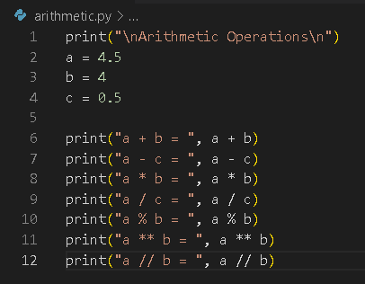
Run the code.
Output:
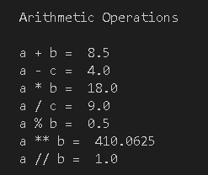

If you look at the results of a – c, a * c, and a / c, even if the respective difference, product, and quotient are whole numbers, Python will convert them into floats if one of the values is a float.

Python Assignment and Augmented Assignment Operators
Assignment operators are used to assign values to variables:
Operator | Example | Same As
= | x = 5 | x = 5
+= | x += 3 | x = x + 3
-= | x -= 3 | x = x - 3
*= | x *= 3 | x = x * 3
/= | x /= 3 | x = x / 3
%= | x %= 3 | x = x % 3
//= | x //= 3 | x = x // 3
**= | x **= 3 | x = x ** 3
&= | x &= 3 | x = x & 3
|= | x |= 3 | x = x | 3
^= | x ^= 3 | x = x ^ 3
>>= | x >>= 3 | x = x >> 3
<<= | x <<= 3 | x = x << 3
:= | print(x := 3) | x = 3  print(x)

1. In your Module01 folder, create a file name assignment_1.py and type the following code:
Run the code.
Output:

2. In your Module01 folder, create a file name assignment_2.py and type the following code:
Run the code.
Output:

Note: The division of either both int and of int with float will produce a quotient of float type.

Python Comparison Operators
Comparison operators are used to compare two values:
Operator | Name | Description | Example
== | Equal | Returns True if the values of two operands are equal | x == y
!= | Not equal | Returns True if the values are not equal | x != y
> | Greater than | Returns True if the value left to the operand is greater than the one on the right | x > y
< | Less than | Returns True if the value left to the operand is lesser than the one on the right | x < y
>= | Greater than or equal to | Returns True if the value left to the operand is greater than or equal to the one on the right | x >= y
<= | Less than or equal to | Returns True if the value left to the operand is lesser than or equal to the one on the right | x <= y

1. In your Module01 folder, create a file name comparison.py and type the following code:

Run the code.
Output:

Python Logical Operators
Logical operators are used to combine conditional statements:
Operator | Description | Example
and | Logical AND. Returns True if both statements are true | x < 5 and x < 10
or | Logical OR. Returns True if one of the statements is true | x < 5 or x < 4
not | Logical NOT. Reverse the result, returns False if the result is true | not (x < 5 and x < 10)

1. In your Module01 folder, create a file name logical.py and type the following code:
Run the code.
Output:

Python Identity Operators
Identity operators are used to compare the objects, not if they are equal, but if they are the same object, with the same memory location:

Operator | Description | Example
is | Returns True if both variables are the same object | x is y
is not | Returns True if both variables are not the same object | x is not y
1. In your Module01 folder, create a file name identity.py and type the following code:
Run the code.
Output:

Look at the ids of the variables a and c, they are identical. The 'is' operator evaluates to True if both the operand objects share the same memory location. The memory location of the object can be obtained by the "id()" function. If the "id()" of both variables is same, the "is" operator returns True.

2. Add the following code to the identiy.py script:
Run the code.
Output:

The 'is not' operator evaluates to True if both the operand objects do not share the same memory location or both operands are not the same objects.

Python Membership Operators
Membership operators are used to test if a sequence is presented in an object:
Operator | Description | Example
in | Returns True if a sequence with the specified value is present in the object | x in y
not in | Returns True if a sequence with the specified value is not present in the object | x not in y

1. In your Module01 folder, create a file name membership.py and type the following code:
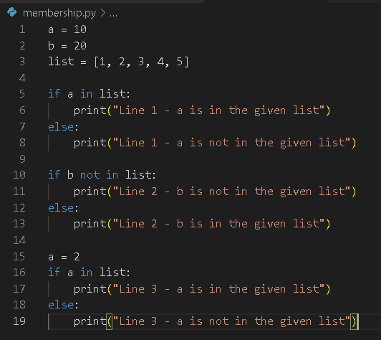
Run the code.
Output:

User Input
To receive information through the keyboard, Python uses the input() function. This function has
an optional parameter, commonly known as prompt, which is a string that will be printed on the
screen whenever the function is called.

When the input() function is called, the program flow stops until the user enters the input via the
command line. To enter the data, the user needs to press the ENTER key after inputting a value.
Once this is done, the entered value will be submitted to the application.

The input() function, by default, will convert all the information it receives into a string even if your input is numeric, like an integer.

1. In your Module01 folder, create a file name user_input.py and type the following code:

.
Run the code

Output:
]

2. Edit your code in the user_input.py script by adding the highlighted code:
Run the code and compare the output from the previous code.

By adding the new line of code age = int(age), this converts the input string value to its numerical representation. When checking the type of the age variable again, the output will be “<class ‘int’>” for integer.

Python Control Flows
Python control flow is regulated by several types of conditional statements, loops, and function calls. By default, the instructions in a computer program are executed in a sequential manner, from top to bottom, or from start to end. However, sequentially executing programs can perform only simplistic tasks. We would like the program to have a decision-making ability, so that it performs different steps depending on different conditions.

Most programming languages, including Python, provide functionality to control the flow of execution of instructions. Normally, there are two types of control flow statements in any programming language and Python also supports them.

Python Decision Making
Decision making is the anticipation of conditions occurring while a program executes and specifying actions to take according to the conditions.

Decision structures evaluate multiple expressions which produce TRUE or FALSE as the outcome. You need to determine which action to take and which statements to execute if an outcome is TRUE or FALSE.

Python programming language assumes any non-zero and non-null values are TRUE, and if they are either zero or null, then they are assumed to be FALSE.

The Conditional Statements

Python provides if..elif..else control statements as a part of decision marking. The following is a simple example which makes use of if..elif..else.

The if statement contains a logical expression in which data is compared and a decision is made based on the result of the comparison.
Syntax:
if expression:
statement(s)

If the Boolean expression evaluates to TRUE, then the block of statement(s) inside the if
statement is executed. If the Boolean expression evaluates to FALSE, then the first set of code
after the end of the if statement(s) is executed.

An else statement can be combined with an if statement. An else statement contains the block of code that executes if the conditional expression in the if statement resolves to a FALSE value.

The else statement is an optional statement and there can only be one else statement following the if statement.
Syntax:
if expression:
statement(s)
else:
statement(s)

1. In your Module01 folder, create a file name if_control.py and type the following code:
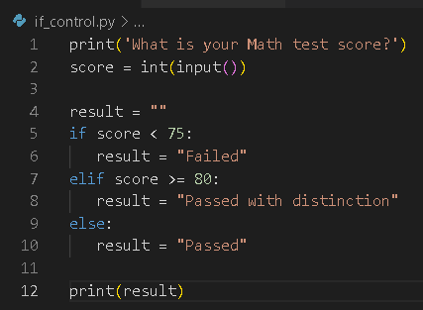
Run the code.
Output:
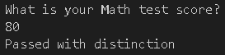

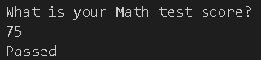

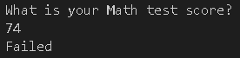

Python Loops
In general, statements are executed sequentially. The first statement in a function is executed first, followed by the second, and so on. There may be a situation when you need to execute a block of code several times.

Programming languages provide various control structures that allow for more complicated execution paths.

Python loops allow us to execute a statement or group of statements multiple times.

In Python, all the statements indented by the same number of character spaces after a programming construct are part of a single block of code. Python uses indentation as its method of grouping statements.

Python while Loop
A while loop statement in Python programming language repeatedly executes a target statement or a group of statements multiple times as long as a given Boolean expression is true.

The while keyword is followed by a Boolean expression, and then by colon symbol, to start an indented block of statements.
Syntax:
while expression:
statement(s)

Here, statement(s) may be a single statement or a block of statements with uniform indent. The condition may be any expression, and true is any non-zero value. The loop iterates while the Boolean expression is true.
As soon as the expression becomes false, the program control passes to the line immediately following the loop.
If it fails to turn false, the loop continues to run and does not stop unless forcefully stopped. Such a loop is called infinite loop, which is undesired in a computer program. You must use caution when using while loops because of the possibility that this condition never resolves to a FALSE value.
If your program gets stuck in an infinite loop, press CTRL-C or just close the terminal window displaying your program's output.
1. In your Module01 folder, create a file name while_control.py and type the following code:
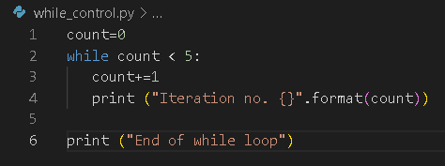
Run the code.
Output:
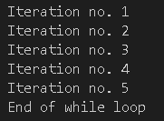

Python while-else Loop
Python supports having an else statement associated with a while loop statement.

If the else statement is used with a while loop, the else statement is executed when the condition becomes false before the control shifts to the main line of execution.

1. In your Module01 folder, create a file name while_else.py and type the following code:
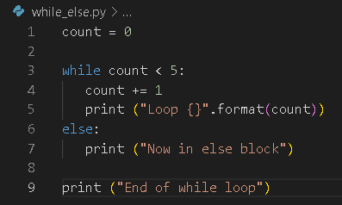
Run the code.
Output:
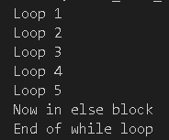

The value of count will be incremented each time, and the condition is checked to see if the count is less than 5. While the count is less than 5, the while loop continues, and when the condition becomes false, the else block of the statement is executed.

Python for Loop

The for loop in Python allows iterating over the items of any sequence (list, tuple, string) in order. This allows you to execute a block of code a fixed number of times.
Syntax:
for interating_var in sequence:
statement(s)

1. In your Module01 folder, create a file name for_control.py and type the following code:
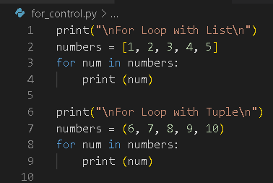
Run the code.
Output:
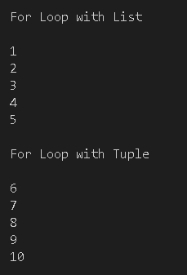

2. Add the following code to the for_control script:
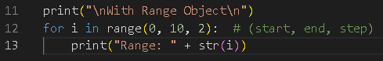
Run the code.
Output:
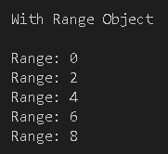

Iterating by Sequence Index
An alternative way of iterating through each item is by index offset into the sequence itself.

3. Add the following code to the for_control script:
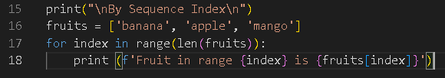
Run the code.
Output:
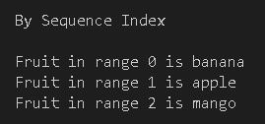

The len() built-in function provides the total number of elements in the list and the range() built-in function gives us the actual sequence to iterate over. So, the length of the fruit is 3 and the range starts from 0 to 2. When the range is 0, banana is printed, when the range is 1, apple is printed, and when the range is 2, mango is printed.

Using else Statement with For Loop
Python supports having an else statement associated with a loop statement.

If the else statement is used with a for loop, the else statement is executed when the loop has exhausted iterating the list.

1. In your Module01 folder, create a file name for_else.py and type the following code:
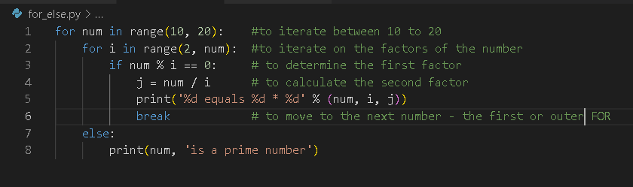
Run the code.
Output:
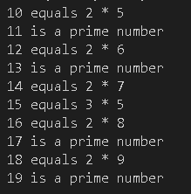

Python Loop Control Statements
Loop control statements change execution from their normal sequence. When execution leaves a scope, all automatic objects that were created in that scope are destroyed.

The break Statement
Python’s break statement is used to terminate the current loop and resumes execution at the next statement.
The most common use for Python break statement is when some external condition is triggered requiring a hasty exit from a loop. The break statement can be used in both Python while and for loops.

If you are using nested loops in Python, the break statement stops the execution of the innermost loop and starts executing the next line of code after the block.

1. In your Module01 folder, create a file name break.py and type the following code:
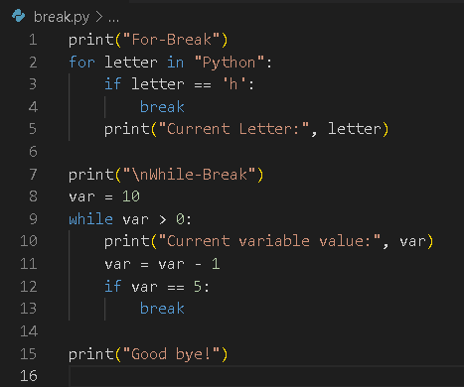
Run the code.
Output:
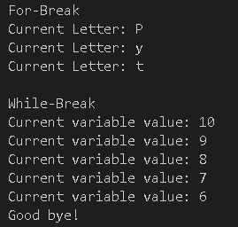

Python’s continue Statement
The continue statement is used to skip the execution of the program block and returns the control to the beginning of the current loop to start the next iteration. When encountered, the loop starts the next iteration and ignores the remaining statements in the current iteration.

The continue statement can be used in both while and for loops.

1. In your Module01 folder, create a file name continue.py and type the following code:
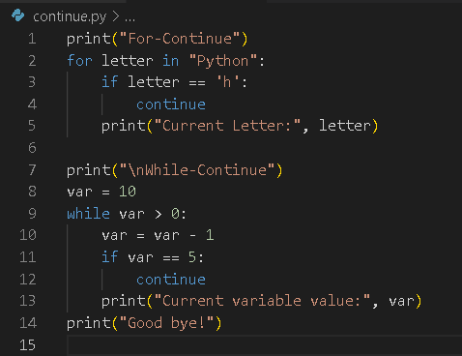
Run the code.
Output:
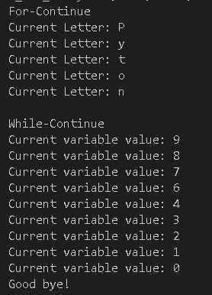

Python Type Casting
Type casting is the process of converting an object from one data type to another data type.

In Python there are different data types, such as numbers, sequences, mappings etc. There may be a situation where you have the available data of one type, but you want to use it in another form. For example, the user has input a string, but you want to use it as a number. Python's type casting mechanism lets you do that.

Python int() Function
Python's built-in int() function converts an integer literal to an integer object, a float to integer, and a string to integer if the string itself has a valid integer literal representation.

Using int() with an int object as argument is equivalent to declaring an int object directly.

1. In your Module01 folder, create a file name data_conversion.py and type the following code:
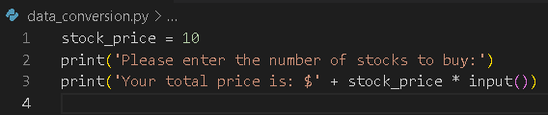

In this example, we are trying to compute the total price of the transaction based on the user’s input.
Try running the code and see the output:
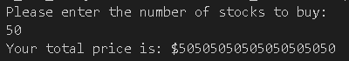

Surprisingly, this is not our expected cost, which is $500. Remember, by default, in Python the user input is a string. If you use this logic, a number * a string, the system will print the input string as many times as the given number. If you count the number of times 50 is printed, it will be 10 times, which is the value of our stock_price variable.

2. We can fix this by explicitly converting the data type to what we want. Update the code as below:
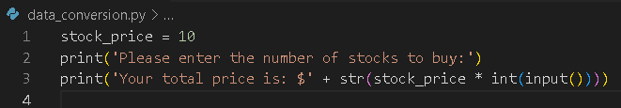

Run the code. Compare the output with the output above.
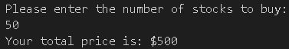

Note: Use int() to convert the input value to an integer and use str() to convert the result of the calculation back to a string. We can also use float() to convert a value to a float number.

3. Update the code, replace int() with float() and run the code. The output will be slightly different.
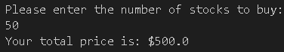

Push your work to GitHub

Follow the instructions on the CityU STC TA Center Github.io Submit your work page
Make sure you are in the correct directory/repository: Desktop/DS522/hos01a-courseName-yourUserName

Run the following commands to push your work to the GitHub repository:
Open the terminal from the VSCode by hitting the control + ~ key and type the following command:
>>> git add .
>>> git commit -m “Submission for HOS01A”
>>> git push

Please answer HOS01B in Brightspace.

